Privacy Preferences for Electronic Medical Records

Write your name here!

July 29, 2022

Contents

Introduction 2

Proposed PPEMR. 3

1 A. Project Planning 4

Use Case Diagram: 8

Data Model 9

Wireframes 9

User Stories 13

1.B. Test Plan 15

Test Script for User Story 1: 15

Test Script for User Story 2: 15

Test Script for User Story 3: 15

Test Script for User Story 4: 16

Test Script for User Story 5: 16

Test Script for User Story 6: 17

Test Script for User Story 7: 17

Test script for user story 1: 17

Test script for user story 2: 18

Test script for user story 3: 18

Test script for user story 4: 18

Test script for user story 5: 19

Test script for user story 6: 19

Test script for user story 7: 19

1. C. Project Evaluation 20

Consider ways in which the application might be improved 21

Personal Reflection 21

Description of the professional, ethical, and legal issues associated with the application 22

# Introduction

***Privacy Preferences for Electronic Medical Records*** (PPEMR) will allow Patients, Doctors, and Healthcare Administrators to access a medical records database. The system will allow Patients to enter decisions about their identifiable data being used for service planning and evaluation, and whether they consent to be contacted for participation in a research study. If they do consent, they will be able to select which organisations they would like to donate their data to for research purposes. The system will also provide basic query facilities for these data, and enable Doctors and Healthcare Administrators to view the Patient’s decisions and information, but not to change them.

This document is the requirements definition of ***Privacy Preferences for Electronic Medical Records***. The document presents the goal and objectives of the system, outlines the scope of the system, and studies the target user types and their level of digital literacy. It defines the functional requirements of the ***Privacy Preferences for Electronic Medical Records*** (for each user type).

## Proposed PPEMR.[1]

The proposed application will provide a password-protected login for patients, doctors, and healthcare administrators, enabling patients to enter decisions about the use of their identifiable data for service planning and evaluation and to consent or decline participation in research studies. If a patient consents to be contacted for a research study, they will be presented with various sharing options and will have the ability to specify which research organisations they are willing to donate their data to. The application will also provide basic query facilities for the recorded data and allow doctors and healthcare administrators to view the decisions and information entered by patients, but not to change them.

The project aims to create a web browser application that allows for the *Privacy Preferences for Electronic Medical Records* in an automated manner. To accomplish this goal, the following objectives must be met by the system:

1. The system must allow the healthcare administrators, doctors & patients to log in to the application with a password.
2. The system must allow the Patient to enter a decision about whether their identifiable data is to be used for service planning and evaluation.
3. The system must allow the Patient’s Electronic Medical Record to store the patient’s decision about the use of their identifiable data.
4. The system must allow the Patient to enter a decision about whether they consent to be contacted for possible participation in a research study.
5. The system must allow the query facilities for the patient to access information in their electronic medical record.
6. The system must allow the doctors to view the decisions and information entered by the Patient
7. The system must allow the healthcare administrators to view the decisions and information entered by the patient

# 1 A. Project Planning

Project management planning involves defining the project’s goals, determining the work required to achieve those goals, and creating a plan for completing the work. The requirements specification is an important part of the planning process, as it outlines the specific needs and expectations for the project. It should include details on the project’s scope, budget, timeline, and deliverables, as well as any constraints or assumptions that will impact the project. Properly defining these requirements is critical to the success of the project, as it helps to ensure that all stakeholders are aligned and that the project stays on track.

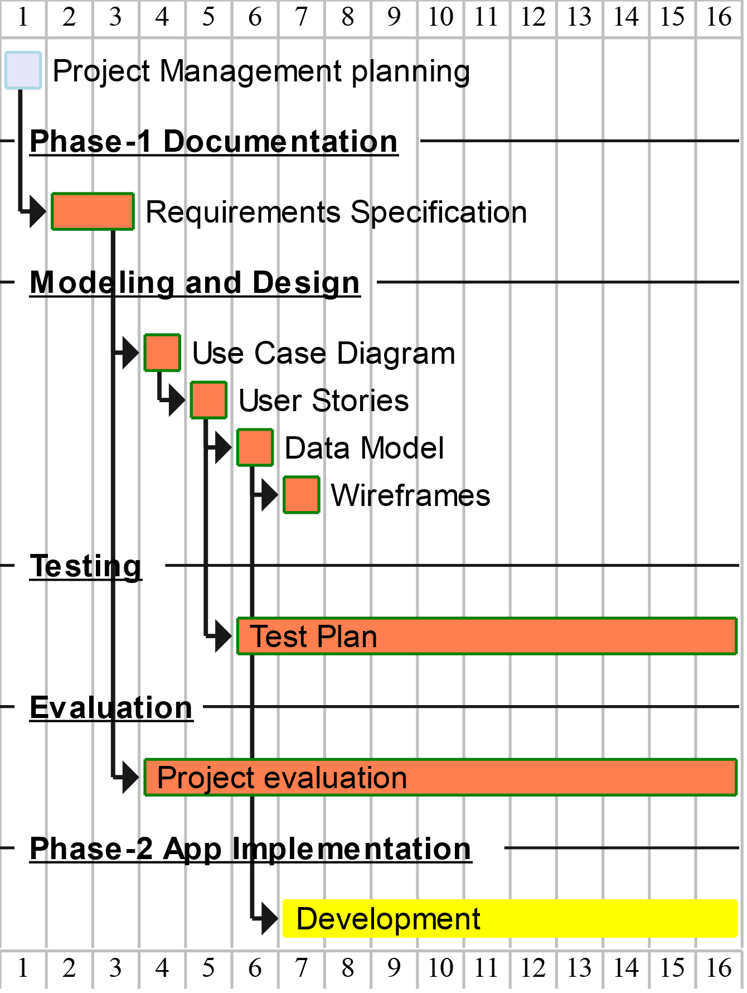

*Gantt chart shows the project plan for the (****PPEMR****)*

***Here is a list of requirements to support the Privacy Preferences for Electronic Medical Records system using an agile approach:***

1. A password-protected login system for patients, doctors, and healthcare administrators.
2. A feature for patients to enter decisions about the use of their identifiable data for service planning and evaluation.
3. A feature for storing the patient's decision about the use of their identifiable data in their electronic medical record.
4. A feature for patients to enter decisions about whether they consent to be contacted for possible participation in a research study.
5. Basic query facilities for patients to access information in their electronic medical records.
6. A feature for doctors to view the decisions and information entered by the patient.
7. A feature for healthcare administrators to view the decisions and information entered by the patient.
8. A feature for patients to select which research organisations they are willing to donate their data to if they consent to participation in a research study.
9. A feature to present patients with various sharing options when they consent to participation in a research study.
10. A system for recording and storing the data shared with research organisations.
11. A system to ensure the confidentiality and security of the data stored in the electronic medical records system.
12. A system for regularly backing up and storing the data in case of any system failures or data loss.
13. A system for maintaining the integrity and accuracy of the data stored in the electronic medical records system.
14. A system for handling and resolving any issues or conflicts that may arise with the data stored in the electronic medical records system.

The key requirements from the **(DifferentFormatForQuestions.pdf)** are:

1. CDDFT is an Acute Hospitals and Community Services Trust that provides a range of medical services for people living in County Durham and Darlington, as well as community health services for people in those areas and broader services to support good health in the North East of England.
2. CDDFT wants to make sure that patients receive the right care at the right time from the right person, and will use information about patients to help plan, deliver, and evaluate health and care services in the North East and North Cumbria to achieve this goal.
3. CDDFT is seeking permission from patients to use their information to improve services, improve health and care services, and improve understanding of health through research.
4. Patients have the option to give permission for their information to be used to improve health and care in North East and North Cumbria.
5. Patients also have the option to be contacted about participating in research about health and care and can specify which types of researchers they are willing to be contacted by (NHS, university or academic researchers, research charities, research by companies for the public good, research by companies for commercial gain).
6. Patients can specify how often they would like to be contacted about research opportunities.
7. Patients have the option to change their preferences at any time by creating a login or calling a provided phone number.

Applying the ***Scrum framework*** to the development of the Privacy Preferences for Electronic Medical Records (PPEMR) system, the following steps can be taken:

1. Form a cross-functional development team consisting of patients, doctors, healthcare administrators, and any other stakeholders who will be involved in the project.
2. Identify and prioritize the most important features of the PPEMR system, and break them down into smaller, manageable units called "user stories."
3. Create a product backlog, a list of all the user stories that need to be completed to achieve the project's goals.
4. Hold a sprint planning meeting to determine which user stories will be included in the first sprint, and assign tasks to team members.
5. During the sprint, the team works on completing the tasks and user stories assigned to them. The team holds daily stand-up meetings to discuss progress and any challenges faced.
6. At the end of the sprint, the team holds a sprint review meeting to demonstrate the completed work to stakeholders and gather feedback.
7. The team also holds a sprint retrospective meeting to reflect on what went well during the sprint and what could be improved in future sprints.

By following this process, the team (me/I/myself) can continuously build and deliver functional increments of the PPEMR system while staying aligned with the project's goals and adapting to any changes that may arise.

The requirement specifications of the PPEMR project according to the agile approach would include:

* A clear and concise description of the project's goals and objectives
* A detailed breakdown of the functional requirements for each user type (patients, doctors, healthcare administrators)
* A timeline for completing the work and delivering the project
* A budget for the project
* A list of any constraints or assumptions that will impact the project
* A plan for managing and prioritizing the work, including how to adapt to changes or unforeseen circumstances. This could involve using a tool such as a Kanban board or using the Scrum framework, which involves organising work into small, incremental cycles called "sprints."
* A method for measuring the progress and success of the project, such as through regular check-ins with stakeholders, demos of completed work, and tracking metrics such as the number of defects found or the speed at which work is completed.

# Use Case Diagram:

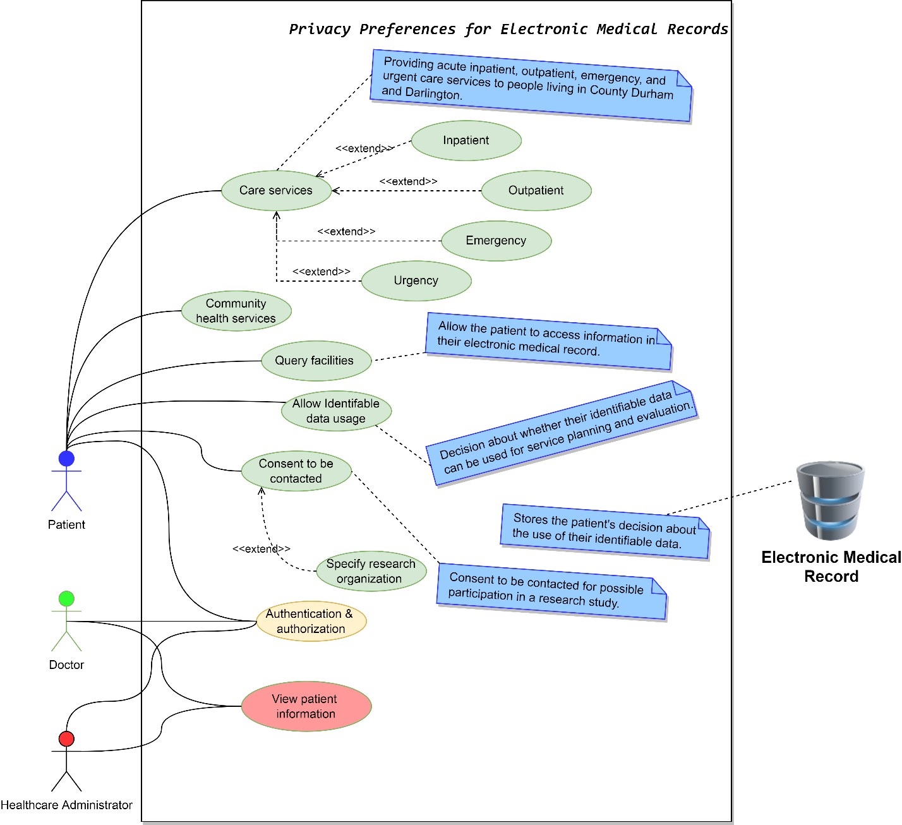

*use case diagram*

# Data Model

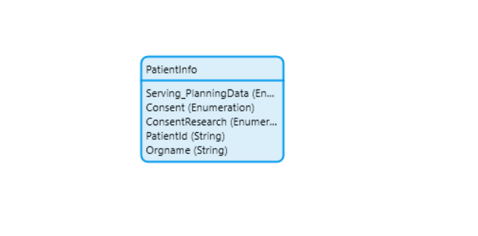

# Wireframes

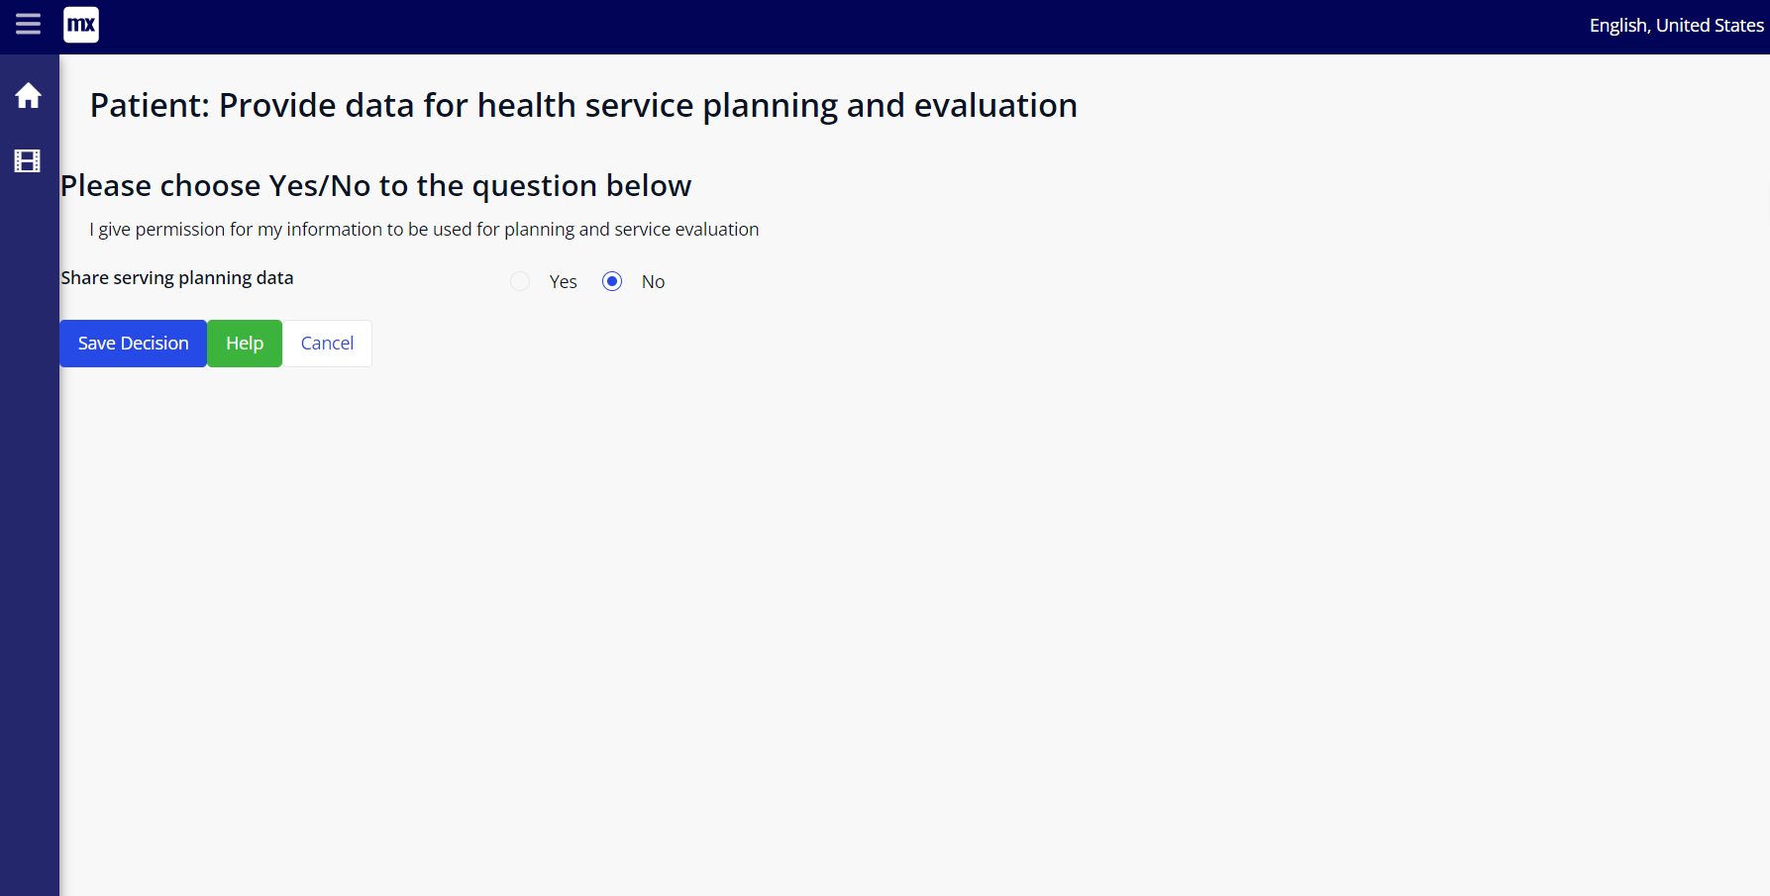

**Doctor and healthcare admin screen**

The main types of users of the system will be:

1. **Patient:** anyone who is seeking medical care and has a password-protected login in a system that includes electronic medical records. He can make decisions about the use of his identifiable data for service planning and evaluation, and can also consent or decline to be contacted for possible participation in research studies. If he does, consents, he has the option to choose which organisations they would be willing to donate their data to for research purposes.
2. **Doctor:** is involved in the use of electronic medical records and will have access to information about a patient’s decisions regarding the use of their identifiable data for service planning and evaluation, as well as their consent for possible participation in research studies. He also can view information that has been entered by a patient in their electronic medical record, but cannot change it.
3. **Healthcare administrators:** a professional who has a password-protected login in a system that includes electronic medical records. He can view the decisions and information entered by patients in their electronic medical records, but cannot change them. It is not clear from the text what the specific responsibilities or duties of the healthcare administrator are, but they may be involved in managing the use and access of patient data for service planning and evaluation, as well as for research purposes.
4. **Patient’s Electronic Medical Record**: a database server which stores the patient’s decision about the use of their identifiable data.

# User Stories

Here are the user stories that had identified from the problem statement:

1. As a **patient**, I **want** to be able to log in to the application with a password **so that** I can access my electronic medical record.
2. As a **patient**, I **want** to be able to enter a decision about whether my identifiable data can be used for service planning and evaluation **so that** my preferences are recorded in my electronic medical record.
3. As a **patient**, I **want** to be able to enter a decision about whether I consent to be contacted for possible participation in a research study **so that** my preferences are recorded in my electronic medical record.
4. As a **patient**, I **want** to be able to see a screen with various sharing options if I consent to be contacted for a research study **so that** I can choose how my data will be shared.
5. As a **patient**, I **want** to be able to enter the names and types of research organizations to that I am willing to donate my identifiable data **so that** my preferences are recorded in my electronic medical record.
6. As a **patient**, I **want** to be able to **use** basic query facilities to access information in my electronic medical record.
7. As a **doctor** or **healthcare administrator**, I **want** to be able to view the decisions and information entered by patients, but not be able to change them.

The user stories from the **(DifferentFormatForQuestions.pdf)** are:

1. As a **patient** of CDDFT, I want to receive the right care at the right time from the right person, so that I can receive the best possible medical treatment.
2. As a **patient** of CDDFT, I want to have access to a range of acute inpatient, outpatient, emergency, and urgent care services, so that I can receive the medical treatment I need.
3. As a **patient** of CDDFT, I **want** to have access to community health services, **so that** I can receive the support I need to maintain my health and well-being.
4. As a **patient** of CDDFT, I **want** to have access to services that support good health in the North East of England**, so that** I can benefit from improved health and well-being in my region.
5. As a **patient** of CDDFT, I **want** to have my information protected, and only used to provide my treatment **so that** my privacy is respected.
6. As a **patient** of CDDFT, I **want** to be asked for permission before my information is used in any other way **so that** I have control over how my information is used.
7. As a **patient** of CDDFT, I **want** CDDFT to use information about me to help plan, deliver, and evaluate health and care services in North East and North Cumbria **so that** I can receive the best possible joined-up services.
8. As a **patient** of CDDFT, I **want** to be asked if I am willing to be contacted about participating in research about health and care **so that** I have the opportunity to contribute to the development of the best services to meet my and the region's needs.
9. As a **patient** of CDDFT, I **want** my information to be used to improve services, improve health and care services, and improve my understanding of health through research **so that** the quality of healthcare in my region can be improved.
10. As a **patient** of CDDFT, I **want** to be able to specify my preferences for how my personal information is used, including permitting its use to improve health and care in North East and North Cumbria, and whether I am willing to be contacted about participating in research.
11. As a **patient** of CDDFT, I **want** to be able to specify which types of researchers I am willing to be contacted by, and how often I would like to be contacted about research opportunities **so that** I have control over how I am contacted about research.
12. As a **patient** of CDDFT, I **want** to be able to change my preferences at any time, **so that** I can update my preferences as my needs and circumstances change.

# 1.B. Test Plan

## Test Script for User Story 1:

|  |  |
| --- | --- |
| **User Instructions** | **Expected outcome** |
| 1. Open the application and navigate to the login page. 2. Enter your username and password. 3. Click the login button. | * The application should allow the user to log in successfully with a valid username and password. * The application should display an error message if an invalid username or password is entered. |

## Test Script for User Story 2:

|  |  |
| --- | --- |
| **User Instructions** | **Expected outcome** |
| 1. Log in to the application with your username and password. 2. Navigate to the page where you can enter a decision about whether your identifiable data can be used for service planning and evaluation. 3. Select either "Yes" or "No" to indicate your decision. 4. Click the submit button. | * The application should record the user’s decision in their electronic medical record. * The application should display a confirmation message indicating that the decision has been saved. |

## Test Script for User Story 3:

|  |  |
| --- | --- |
| **User Instructions** | **Expected outcome** |
| 1. Log in to the application with your username and password. 2. Navigate to the page where you can enter a decision about whether you consent to be contacted for possible participation in a research study. 3. Select either "Yes" or "No" to indicate your decision. 4. Click the submit button. | * The application should record the user’s decision in their electronic medical record. * If the user selects "Yes," the application should display a screen with various sharing options. * The application should display a confirmation message indicating that the decision has been saved. |

## Test Script for User Story 4:

|  |  |
| --- | --- |
| **User Instructions** | **Expected outcome** |
| 1. Log in to the application with your username and password. 2. Navigate to the page where you can enter a decision about whether you consent to be contacted for possible participation in a research study. 3. Select "Yes" to indicate that you consent to be contacted. 4. Click the submit button. | 1. The application should display a screen with various sharing options. 2. The user should be able to select from the available sharing options. |

## Test Script for User Story 5:

|  |  |
| --- | --- |
| **User Instructions** | **Expected outcome** |
| 1. Log in to the application with your username and password. 2. Navigate to the page where you can enter the names and types of research organizations to that you are willing to donate your identifiable data. 3. Enter the name of a research organisation in the provided field. 4. Select the type of organization from the dropdown menu. 5. Click the submit button. | * The application should record the user’s selection in their electronic medical record. * The application should display a confirmation message indicating that the selection has been saved. |

## Test Script for User Story 6:

|  |  |
| --- | --- |
| **User Instructions** | **Expected outcome** |
| 1. Log in to the application with your username and password. 2. Navigate to the page where you can access basic query facilities for your electronic medical record. 3. Enter a search query in the provided field. 4. Click the search button. | * The application should return the relevant information from the user’s electronic medical record. * The application should display an error message if no results are found for the search query. |

## Test Script for User Story 7:

|  |  |
| --- | --- |
| **User Instructions** | **Expected outcome** |
| 1. Log in to the application with your username and password as a doctor or healthcare administrator. 2. Navigate to the page where you can view the decisions and information entered by patients. | * The application should return the relevant information from the user’s electronic medical record. * The application should display an error message if no results are found for the search query. |

The testscript for the user stories from the **(DifferentFormatForQuestions.pdf)** are:

## Test script for user story 1:

|  |  |
| --- | --- |
| **User Instructions** | **Expected outcome** |
| **Step 1:** As a patient of CDDFT, access the patient portal and log in to your account.  **Step 2:** Navigate to the appointment scheduling page and schedule an appointment with a healthcare provider of your choice.  **Step 3:** Attend the appointment at the specified time and location. | You receive the right care at the right time from the right person, as indicated by the healthcare provider being present at the appointment and providing appropriate medical treatment. |

## Test script for user story 2:

|  |  |
| --- | --- |
| **User Instructions** | **Expected outcome** |
| **Step 1:** As a patient of CDDFT, access the patient portal and log in to your account.  **Step 2:** Navigate to the services page and browse the available acute inpatient, outpatient, emergency, and urgent care services.  **Step 3:** Select a service that you require and schedule an appointment for that service. | You have access to a range of acute inpatient, outpatient, emergency, and urgent care services and are able to schedule appointments for those services as needed. |

## Test script for user story 3:

|  |  |
| --- | --- |
| **User Instructions** | **Expected outcome** |
| **Step 1:** As a patient of CDDFT, access the patient portal and log in to your account.  **Step 2:** Navigate to the services page and browse the available community health services.  **Step 3:** Select a community health service that you require and schedule an appointment for that service. | You have access to community health services and are able to schedule appointments for those services as needed. |

## Test script for user story 4:

|  |  |
| --- | --- |
| **User Instructions** | **Expected outcome** |
| **Step 1:** As a patient of CDDFT, access the patient portal and log in to your account.  **Step 2:** Navigate to the services page and browse the available health services in the North East of England.  **Step 3:** Select a health service that you require and schedule an appointment for that service. | You have access to services that support good health in the North East of England and are able to schedule appointments for those services as needed. |

## Test script for user story 5:

|  |  |
| --- | --- |
| **User Instructions** | **Expected outcome** |
| **Step 1:** As a patient of CDDFT, access the patient portal and log in to your account.  **Step 2:** Navigate to the privacy settings page and review the policies and procedures in place to protect your information. | Your information is protected and only used to provide your treatment, as indicated by the presence of appropriate privacy policies and procedures. |

## Test script for user story 6:

|  |  |
| --- | --- |
| **User Instructions** | **Expected outcome** |
| **Step 1:** As a patient of CDDFT, access the patient portal and log in to your account.  **Step 2:** Navigate to the privacy settings page and review the options for giving or withholding permission for the use of your information in ways other than providing your treatment.  **Step 3:** Select your preferred option for giving or withholding permission for the use of your information in ways other than providing your treatment. | You are asked for permission before your information is used in any other way, and have control over how your information is used. |

## Test script for user story 7:

|  |  |
| --- | --- |
| **User Instructions** | **Expected outcome** |
| **Step 1:** As a patient of CDDFT, access the patient portal and log in to your account.  **Step 2:** Navigate to the privacy settings page and review the options for giving or withholding permission for the use of your information to help plan, deliver, and evaluate health and care services in the North East and North Cumbria.  **Step 3:** Select your preferred option for giving or withholding permission for the use of your information in this way. | CDDFT uses your information to help. |

# C. Project Evaluation

The application for Privacy Preferences for Electronic Medical Records (PPEMR) is a web browser application that allows patients, doctors, and healthcare administrators to access a medical records database. The system allows patients to enter decisions about their identifiable data being used for service planning and evaluation, and whether they consent to be contacted for participation in a research study. If they do consent, they can specify which research organisations they would like to donate their data to. The system also provides basic query facilities for the recorded data and allows doctors and healthcare administrators to view the decisions and information entered by patients, but not to change them. The application has the following functional requirements: password-protected login, the ability for patients to enter decisions about the use of their identifiable data, the ability for the Electronic Medical Record to store these decisions, the ability for patients to enter a decision about participating in a research study, basic query facilities for patient access to their electronic medical record, the ability for doctors and healthcare administrators to view decisions and information entered by patients, and the ability for healthcare administrators to view and export data for service planning and evaluation. It is designed to meet the goal of creating an automated system for privacy preferences in electronic medical records and the objectives of allowing for password-protected login, storing patient decisions about the use of their identifiable data, allowing patients to enter decisions about participating in research studies, providing query facilities for patient access to their electronic medical record, and allowing doctors and healthcare administrators to view decisions and information entered by patients. The project has a defined scope, budget, timeline, and deliverables, as well as identified constraints and assumptions. A Gantt chart is provided to show the project plan.

## Consider ways in which the application might be improved

Based on the provided text, the Privacy Preferences for Electronic Medical Records (PPEMR) application appears to be a complete solution for allowing patients, doctors, and healthcare administrators to access a medical records database and manage privacy preferences for the use of identifiable data. The application meets the goal of creating an automated system for managing privacy preferences in electronic medical records and has defined functional requirements for each user type. The project has a defined scope, budget, timeline, and deliverables, as well as identified constraints and assumptions. A Gantt chart is provided to show the project plan.

To improve the application, some potential areas for consideration could include:

1. Adding additional security measures to protect patient information, such as multi-factor authentication or encryption.
2. Expanding the available options for patients to specify their preferences for the use of their identifiable data and participation in research studies.
3. Adding more advanced query facilities for doctors and healthcare administrators to allow them to more easily access and analyse data for service planning and evaluation.
4. Implementing a system for tracking and reporting on the use of patient data to ensure compliance with privacy preferences.
5. Adding the ability for patients to easily update or change their privacy preferences over time as their needs or circumstances change.

## Personal Reflection

Throughout this module, I have gained a deeper understanding of the importance of privacy preferences in electronic medical records systems and the need for a system that allows patients to control the use of their identifiable data. I have learned about the various user types that may access such a system, including patients, doctors, and healthcare administrators, and the different functional requirements that may be needed for each user type. I have also learned about the importance of project planning and the role of the requirements specification in outlining the specific needs and expectations for a project.

One skill that I have developed during this module is the ability to analyse and evaluate the completeness of a solution for a given problem or need. In analysing the Privacy Preferences for Electronic Medical Records (PPEMR) system, I have been able to identify the goals, objectives, and functional requirements of the system and determine whether they are sufficient to meet the needs of the various user types.

Moreover, I have gained a greater understanding of the importance of project management in ensuring the success of a project. I have learned that defining the project's goals and creating a plan for completing the work is a crucial step in the planning process, and that properly defining the project's requirements is essential to aligning all stakeholders and keeping the project on track. I also developed insight about the role of Gantt charts in project management and how they can be used to visualize the progress of a project and identify potential issues or delays.

Furthermore, I have also gained a deeper understanding of the agile approach to project management. The use of an agile approach for the development of the Electronic Medical Records system involves breaking the project down into smaller chunks of work called "sprints," which allows for frequent adjustments and updates to the project plan based on feedback from stakeholders. This iterative process emphasizes flexibility, collaboration, and rapid iteration, and is designed to produce high-quality results in a timely manner. Last but not the least, I have gained valuable insights into the importance of effective project management and the benefits of using an agile approach in the development process.

Overall, this module has helped me to understand the importance of properly defining and managing the requirements for a project to ensure its success.

## Description of the professional, ethical, and legal issues associated with the application

The professional, ethical, and legal issues associated with this application include:

1. **Professionalism:** The system should be designed and implemented in a professional manner, following best practices and industry standards. This includes ensuring the security and confidentiality of patient data, as well as following relevant laws and regulations.
2. **Ethics:** The system should ensure that patient privacy is respected and that patient decisions about their data are honoured. It should also be designed to protect patients from harm or exploitation and ensure that their informed consent is obtained for any research studies.
3. **Legal issues:** The system should comply with relevant laws and regulations, including those related to data protection and privacy of the respective country where the system will be deployed. It should also follow guidelines for research ethics and informed consent, as well as any relevant laws related to healthcare.

1. PPEMR stands for **Privacy Preferences for Electronic Medical Records**